HHS GUIDANCE
9th Grade Information Packet

Also available on Guidance Website http://htownguidance.weebly.com/
College Prep Timeline:
All year long:
- Keep your grades up.
- Check the Guidance Website and your Office 365 e-mail account for important information: http://htownguidance.weebly.com/
- Get involved!
- Take advantage of service-learning opportunities.
- Take a rigorous course load that you can reasonably handle.
- Build rapport with teachers and staff. You will need people to write you letters of recommendation when it comes time to apply to college. Having a good rapport with your teachers will help them write you strong letters of recommendation.
Fall of Freshman Year
- Take the PSAT in mid-October
  - Khan Academy has teamed up with Collegeboard to create some great SAT preparation
Spring/Summer:
- College visits. Meet with admissions counselors; go on tours.
  - If you need a transcript, you will need to fill out a Transcript Request form and have your parent/guardian sign it. These can be found in the Guidance Office.

If CTA is a potential option for your pathway, it is important that you take graduation requirements (PE/Health I, Fine Art, Tech Ed, Financial Literacy) during freshman and sophomore years so that you have room in your schedule for CTA. There are some important things to know for students interested in attending the Career Technology Academy (CTA):
- You can only attend CTA in 11th and 12th grade
- In 11th grade, you will have English at CTA (unless you are part of the Cosmetology or the Fire Fighter/EMT programs. In that case, you will have English at Huntingtown). In 12th grade, English will be at HHS.
- You will attend CTA for half the school day.
- There are 2 runs to CTA—morning and afternoon. The morning run takes up periods 1-4 at HHS. The afternoon run takes most of lunch and periods 6-8. We have no control over which run you get so you cannot request a specific run. CTA has to schedule students from 4 different high schools so we have to accommodate their schedule.

COMMUNICATION
School e-mail: Every student has been given an Office 365 e-mail account. Check it regularly and frequently! Your counselor is forwarding you scholarships, opportunities, job openings, etc. regularly, and you want to make sure you’re getting this information. Also, your counselor will be using this as a major form of communication during your senior year, which time is crucial to maintain open communication with your counselor!
- How to access your school Office 365 Outlook account:
      - Calvert County Public Schools website
      - Click on Students tab
      - At the bottom, in the box that says Online Tools, click on Office 365

HAC: It is important that you are checking your grades and keeping up with them just as much as your parents. All middle and high school students need to login to Home Access Center (HAC) using their Student ID and email password.
An ‘s’ should be put at the beginning of the Student ID so a student with an ID of 12345 would login to HAC with:
UserName: s12345
Password: (email password --- same password used to login to Office365)

Guidance Website/Weebly
Documents, forms, information, and resources can be found on the HHS Guidance Weebly webpage. To visit this site, go to - https://htownguidance.weebly.com/
There are tabs for each grade level that has important information specific to that grade. The “blog” posts announcements, opportunities, scholarships, events, etc. for all grade levels. The blog is updated daily as new postings are received in the Guidance office.

Work Permits
The Guidance office is no longer a part of the process for obtaining a work permit. Works permits are done all online on ethe DLLR Maryland website.

Clubs/Sports/Organizations
Get involved! It makes your high school experience a much more pleasant one, and it makes you a well-rounded student, which is what most colleges are looking for. Once you’re in a sport/club/organization, look for opportunities to lead. You don’t have to be president of a club or team captain, just take responsibility willingly and head a few things up.

Tutoring options
If you’re struggling in a class, see your teacher during lunch when they are available and talk to your teacher! It is important that you show your teacher that you care about your grade and that you are willing to make an effort to improve your grade.
- As a rule, all teachers from their department are available on these days:
  - Monday—Social Studies
  - Tuesday—Math
  - Wednesday—Science
  - Thursday—English
  - Friday—Electives Related/Fine Arts
- There is after school tutoring available Tuesdays from 2:30-3:30 in the Media Center. Please see your counselor for more information. Students MUST have transportation if they decide to stay after school for tutoring.

Service Learning
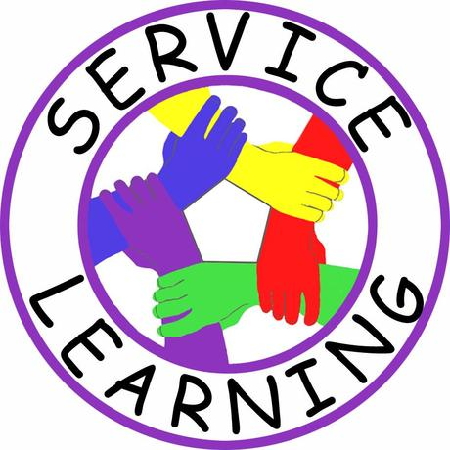
If you have service-learning hours that still need to be completed before graduation, get them done as soon as possible! Summer is the perfect time to get them done. Service-learning information, ideas, and verification forms that needs to be signed by whoever supervised you and also for a list of Calvert County Public Schools service-learning partnerships can be found on the Guidance weebly site or Schoology page. If you want to complete your hours with an organization that is not on the list, you must submit a request to the Guidance Secretary for approval. Once it is approved, you will be able to complete your hours. Don’t forget to turn your Verification Form in!

There are A LOT of scholarships that require community service, so it is a good idea to go above the required 75 hours. Plus, it looks good on a resumé and college application.

Driver’s Education
There is no driver’s education program available through Calvert County Public Schools. You can use any accredited/certified driver’s education program (a Learner’s Permit is required to take the course).
Learner’s Permit
If you are under the age of 16, Maryland law states, you must get the MVA verification of attendance from signed by the attendance office. You must have the top portion filled out with the applicant’s signature and the parent/guardian signature before taking it to the attendance office. DO NOT OPEN the envelope before taking it to the MVA. The MVA will NOT accept any envelope that appears to have been opened.
Mentorship/Job Shadowing
There is a Community Mentorship and Job Shadowing program available through CCPS for 11th and 12th grade students. This is a great opportunity to gain real-world experience in a chosen career field. Click the link for more information https://cccweb.calvertnet.k12.md.us/programs.
The CCPS contact for this program is Ms. Michelle McGuffin. Please contact her at McGuffinM@calvertnet.k12.md.us for any questions.
.

FINAL NOTE: The Guidance website and blog are regularly updated with important information. Please refer to them if you have questions about upcoming dates and deadlines. Also, make sure your Parent/Guardian e-mail and phone numbers are updated in HAC in order to receive regular updates about upcoming school information.

