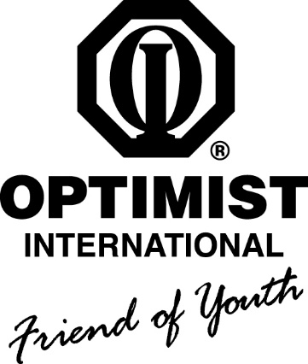 | SCHOLARSHIP  ESSAY CONTEST

Sponsored by:
The Optimist Club of Calvert Prince Frederick
Club #33053

TOPIC: “Chasing Optimism in the Face of Challenges”

- Open to students under the age of 18 as of October 1, 2016
- Essays must be 700-800 words
- Club- and District-level awards
- District First Place Winner will be awarded $2,500 scholarship
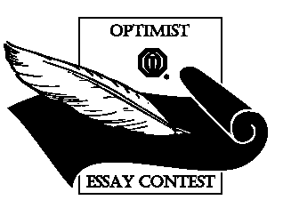
Visit the Guidance Department or contact the Club Chair*
for Official Rules & Contest Application

All essays must be submitted by Friday, January 27, 2017

*Essay Contest Club Chair:
Carey Taylor
careyyoung.cy@gmail.com; 301-481-7069

