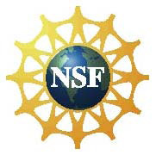**On RAMP to STEM**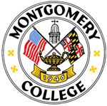

**Scholarships**

**STEM – Science, Technology, Engineering, and Math**

***Full-time scholarship for fall 2017 to attend Montgomery College!***

**Application Deadline for fall 2017 is**

**May 15, 2017.**

**For consideration, FAFSA must be complete and on file with Financial Aid by**

**May 15, 2017**

**Students majoring in life sciences, biotechnology, or mathematics or students with an interest in the interdisciplinary nature of biosciences should apply!**

[**http://www.montgomerycollege.edu/onramp**](http://www.montgomerycollege.edu/onramp)

|  |  |  |
| --- | --- | --- |
| Doc3-1 | **Support from**  **the National Science Foundation**  March 2017 | http://www.racoindustries.com/barcodegenerator/2d/barcode-image.axd?S=QRCode&BM=0.25&C=http%3a%2f%2fwww.montgomerycollege.edu%2fonramp&IFMT=Gif&QRE=Auto&QREC=M&QRV=Auto&QZ=0.25&TM=0.25&MS=0.04 |

March 2013