HHS Senior Class Fundraiser
Tuesday, March 7th
4 pm – 9 pm
Salsarita’s & Sweet Frog
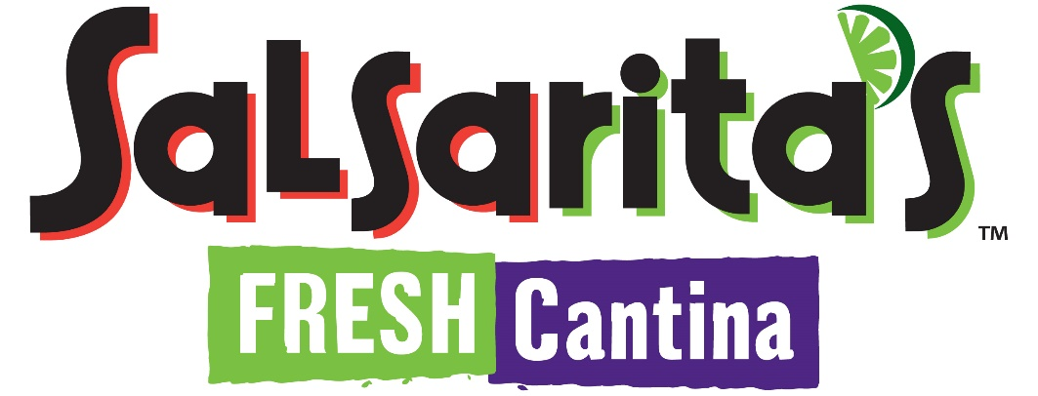
Thank you for supporting the Class of 2017!

