NSA Internship Application Period Starts Early This Year
June 11, 2019

If you’ve got your sights set on landing an internship at the National Security Agency for the summer of 2020, now is the perfect time to put those finishing touches on your resume. The application period for the majority of internships will open Aug. 1, a full month sooner than usual. Plus, the deadlines have been moved to up to Oct. 15 rather than the end of October.

Caitlin Z., manager of NSA’s Summer Intern Program, says the change will allow extra time for the security clearance process. A TS/SCI clearance is required for everyone who works for the agency, and it can take several months to complete the process. But it’s totally worth the wait, says Caitlin. “You can do things at NSA that you can’t do anywhere else,” she says. The mission of protecting the country is a big draw for applicants, and by interning at the agency “you’re setting yourself up well for the future to get a full-time job at NSA after you graduate.” NSA has more than 20 different internships on tap for summer 2020. Undergrads, graduate students and Ph.D. candidates can gain real-world work experience in fields like cybersecurity, computer science, installation and logistics, business, HR and more.
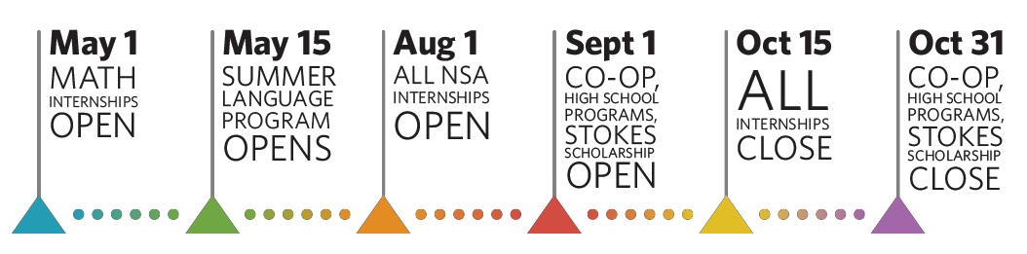

In fact, NSA has three math-heavy internships that are already accepting applications: the Graduate Mathematics Program and the Director’s Summer Program and Cryptanalysis and Signals Analysis Summer Program. The Summer Language Program just opened on May 15. Other student opportunities like the Co-op Program, Stokes Scholarship and high school programs will accept applications Sept. 1 to Oct. 31.
Besides the opportunity to do real work alongside top professionals, interns earn a competitive salary with paid time off. You can also participate in extracurricular activities, and could be
eligible for housing assistance, depending on how far away you live from NSA’s headquarters in Fort Meade, Md.

Caitlin says last year’s interns toured various intelligence agencies and got to take on the CIA’s interns in a paintball game. Plus, the complexes where interns live during the summer have pools and grills, which give students an opportunity to socialize outside work. With NSA located
halfway between Baltimore and Washington, D.C., there’s plenty of tourist attractions to visit, too.

The intern experience at NSA is “not all work, it’s a lot of fun, too,” says Caitlin.
For more information about summer internships and other student opportunities, a great place to get started on your research is NSA’s Student Programs page. For specific questions, contact the Office of Student Programs at 410-854-4726 or email Summer_Interns@nsa.gov.

