Tri-County Maryland Alumnae Chapter
Delta Sigma Theta Sorority, Inc.
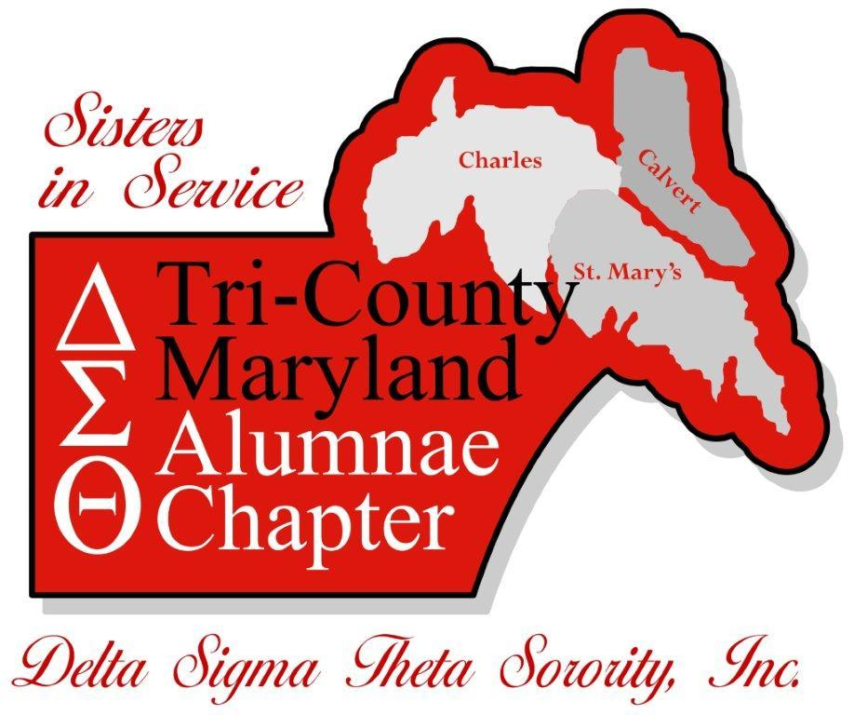

2017 - 2018
Elvear B. Johnson, PhD
Scholarship Application

Application Deadline: Friday, March 30, 2018*
*Must be postmarked by 3/30/2018

For questions, please contact Raven Manigault or Zandra Isaac
Email: tcmdacscholarshipdst@gmail.com
Tri-County Maryland Alumnae Chapter
Delta Sigma Theta Sorority, Inc.
Elvear B. Johnson, Ph.D. Scholarship

Delta Sigma Theta Sorority, Inc was founded in 1913 by 22 students at Howard University. These young women used their collective strength to promote academic excellence; to provide scholarships; to provide support to the underserved; educate and stimulate participation in the establishment of positive public policy; and to highlight issues and provide solutions for problems in their communities.
Delta Sigma Theta Sorority, Inc is a private, nonprofit, organization whose purpose is to provide assistance and support through established programs in local communities throughout the world. A sisterhood of more than 200,000 predominately Black college educated women, the Sorority currently has over 900 chapters located in the United States, England, Japan (Tokyo and Okinawa), Germany, the Virgin Islands, Bermuda, the Bahamas and the Republic of Korea. The major programs of the sorority are based upon the organization’s Five Point Programmatic Thrust:
- Economic Development
- Educational Development
- International Awareness and Involvement
- Physical and Mental Health
- Political Awareness and Involvement
The Tri-County Maryland Alumnae Chapter (TCMDAC) was chartered on March 27, 2011 and our service area includes Calvert, parts of Charles, and St. Mary’s counties. In support of educational development and academic excellence, the TCMDAC is offering the Elvear B. Johnson (Ph.D.) Scholarship in memory of Dr. Johnson, one of the original members of the TCMDAC’s chartering team who passed away prior to completion of the chartering process.
Dr. Johnson graduated from Howard University in 1961 with a Bachelor of Science degree in Chemistry. At Howard, she joined her beloved Delta Sigma Theta Sorority, Inc. In 1975, she received a Master of Arts in Public Administration from the University of Northern Colorado; a Master in Education in Guidance and Counseling in 1981 from the University of Maryland, and received her Doctorate of Philosophy from George Mason University in 2002.
During her long career abroad and here in the United States, she served as a classroom teacher, guidance counselor, staff developer, specialist to the superintendent, and principal. She retired in 2006 from the Charles County Public Schools after 36 years as an educator and administrator. From Dr. Johnson’s passion and commitment to education and academic excellence, this scholarship will be awarded, in her honor, to a high school senior residing in Calvert, Charles and St. Mary’s County who plans to study in the areas of Education, Liberal Arts, Science, Technology, Engineering or Math. Scholarships will be awarded based on academic achievement, written essay and school and community involvement.
Scholarship Amount: $500.00 +
Scholarship Criteria: Students applying for the Elvear B. Johnson Scholarship must meet the following criteria:
- Reside or attend a public school in the TCMDAC service area, which includes all of Calvert and St. Mary’s Counties and Charles County (east of 301). The public high schools in our service area include La Plata, St. Charles, Thomas Stone, Career & Technology Academy, Calvert, Huntingtown, Northern, Patuxent, Chopticon, Great Mills, Leonardtown and the James A. Forrest Career & Technology Center;
- Be a high school senior with a grade point average of 3.0 or above;
- Be able to demonstrate community or extracurricular involvement;
- Be accepted by or planning to attend an accredited four year university or college as a full-time student beginning in the fall of 2018;
- Be planning to pursue a major in one of the following areas: Education, Liberal Arts, Science, Technology, Engineering or Math; and
- Complete the application as instructed.
Application Requirements: All scholarship applicants should submit the following:
- A completed and signed application;
- A list all academic awards, school and community service involvement;
- An official copy of your high school transcript, including the first semester of your senior year from current high school in an envelope sealed and signed by a school official;
- A copy of your SAT or ACT scores sent directly from your high school in an envelope sealed and signed by a school official;
- One current 2017/2018 letter of recommendation from a community service representative regarding current community service. The letter must be 1) signed; 2) on the organization’s letterhead; and 3) in a sealed envelope addressed to Tri-County MD Alumnae Chapter;
- One current 2017/2018letter of recommendation from a school official (i.e. teacher, principal, counselor, etc.). The letter must be 1) signed; 2) on official school letterhead; and 3) in a sealed envelope addressed to Tri-County MD Alumnae Chapter;
- A typed one page essay on why you chose education, science, technology, engineering or math as a career choice or a one page essay describing a community service project. (Maximum of one typewritten page, double spaced, 12-pt font).
- A wallet size original photograph (no proofs or personality shots); and
- A copy of the acceptance letter from a four year university or college (must be provided if awarded the scholarship);
Competitive Factors Include:
- A completed application;
- Demonstrated academic excellence;
- Demonstrated school and community service involvement; and
- A written essay.
Submit application (in its original format) along with attachments, official transcript, photo and recommendations with a postmark no later than March 30, 2018 to:
Tri-County MD Alumnae Chapter
Delta Sigma Theta Sorority, Inc.
Attn: Scholarship Committee
P.O. Box 1956
Leonardtown, MD 20650

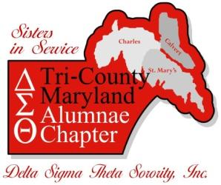
Tri-County Maryland Alumnae Chapter
Delta Sigma Theta Sorority, Incorporated
2017 - 2018 Scholarship Application

Name: ____________________________________________________________________
Address: ____________________________________________________________________
(Street Address)
_______________________ _________________ _______________________ (City) (State) (Zip Code)
Telephone Number: ___________________ Date of Birth: ___________
High School: _________________________
Overall GPA: _________________________
(Most current)

College/Intended College: _____________________________________________________
Formally Accepted: Yes____ No ____
Potential Major: ________________________________________________________
Is your Mother a member of Tri-County Maryland Alumnae Chapter
Applicant’s Signature: __________________________________________________________
Parent/Guardian Signature: ______________________________________________________
Date: _______________________________________________________________________
**Please attach a wallet size photograph with your application.
(For Sorority Use Only)
SCHOLARSHIP APPLICANT CHECKLIST

- All questions answered completely.

- Typed application signed by student.

- Typed essay (Maximum of 1 typewritten page double spaced, 12 pt. font).

- A signed letter of recommendation from a community service representative on organizational letterhead.

- A signed letter of recommendation from a school official on school letterhead.

- List of all awards, school and community service involvement.

- An official copy of your high school transcript, including the first semester your senior year from current high school in an envelope sealed and signed by a school official.

- A copy of your SAT or ACT scores sent directly from your high school in an envelope sealed and signed by a school official.

- Wallet photograph with full name printed on the back. No proofs or personality photos.

Application postmarked no later than Friday, March 30, 2018

Forward completed application to:
Tri-County MD Alumnae Chapter (TCMDAC)
Delta Sigma Theta Sorority, Inc.
Attn: Scholarship Committee
P.O. Box 1956
Leonardtown, MD 20650

This checklist does not override any instructions listed within the scholarship application. Please adhere to all detailed instructions contained within the application packet. Incomplete applications will not be considered.

